Product title: Microsoft Excel 2016 Data Analysis and Business Modeling
ISBN: 9781509304219
Page or location | Errata
3 | Location on page: bottom – autosum range is wrong  Reads:  A quicker way to create our totals is to select the range H23:H28 and (after holding down the Ctrl key) select the range E30:G30. Then simply click the AutoSum button in the Editing group on the Home tab of the ribbon, as shown in Figure 1-3.  Should read:  A quicker way to create our totals is to select the range H23:H28 and (after holding down the Ctrl key) select the range E29:G29. Then simply click the AutoSum button in the Editing group on the Home tab of the ribbon, as shown in Figure 1-3.
6 | Location on page: Multiple references and multiple paragraphs on page 6  Reads:  The number of customers quitting each month is the starting customers multiplied by the churn rate. Therefore, in column E we compute the number of customers that quit each month by copying from E8 to E9:E18 the formula =$C$4*C8 or C$4*C8. Note here that the numeral 8 does not use the dollar sign because when it’s copied, we want 8 to change to 9, 10, and so on.  The ending value for customers for each month is obtained by adding starting customers and new customers and then subtracting quitting customers. Copying from F8 to F9:F18 the formula =C8+D8-F8 computes each month’s ending customers.  For months 2–10, starting customers will equal the previous month’s ending customers, so copy from C9 to C10:C17 the formula =F8. We find (don’t worry about the fraction) that after 10 years, our health club will have around 127 customers.  Should Read:  The number of customers quitting each year is the starting customers multiplied by the churn rate. Therefore, in column E we compute the number of customers that quit each year by copying from E8 to E9:E18 the formula =$C$4*C8 or C$4*C8. Note here that the numeral 8 does not use the dollar sign because when it’s copied, we want 8 to change to 9, 10, and so on.  The ending value for customers for each year is obtained by adding starting customers and new customers and then subtracting quitting customers. Copying from F8 to F9:F18 the formula =C8+D8-F8 computes each year’s ending customers.  For years 2–10, starting customers will equal the previous year’s ending customers, so copy from C9 to C10:C17 the formula =F8. We find (don’t worry about the fraction) that after 10 years, our health club will have around 127 customers.
8 | Location: problem 4, change xt to x1  Reads:  4. The famous butterfly effect states that if a butterfly flaps its wings in Tahiti, that small event might cause a hurricane to hit Texas. Suppose that weather at time t is always between 0 and 1 and is governed by xt+1=4*xt*(1-xt). For xt = 0.3 and xt=.3000001, determine x1, x2, … x50. How do your calculations illustrate the butterfly effect?  Should read:  4. The famous butterfly effect states that if a butterfly flaps its wings in Tahiti, that small event might cause a hurricane to hit Texas. Suppose that weather at time t is always between 0 and 1 and is governed by xt+1=4*xt*(1-xt). For x1 = 0.3 and x1=.3000001, determine x1, x2, … x50. How do your calculations illustrate the butterfly effect?
8 | Location on page: Answer to question 6  Description of error: In the solution downloaded for question 6 (Gini), the first part of the formula is indicated incorrectly (the match is correct though). In cell P12, the formula is [ n + 1/n ], whereas it should be [ (n+1)/n ]. The solution in cell Q12 is correct.
19 | Location on page: Problem 2  Reads:  2. Open a worksheet and name the range containing the cells A1:B3 and A6:B8 as Red.  Should read:  2. Open a worksheet and name the range containing the cells A1:B3 and A6:D8 as Red.
26 | Location: last line in paragraph at bottom  Reads:  If you borrow money from the bank for any duration from 1 through 30 years that’s not listed in the table, your rate is found by interpolating the appropriate number between the rates given in the table. For example, let’s say you borrow money for 15 years. Because 15 years is one quarter of the way between 10 years and 30 years, the annual loan rate would be calculated as follows: .25*.09 + .75*.10.  Should Read:  If you borrow money from the bank for any duration from 1 through 30 years that’s not listed in the table, your rate is found by interpolating the appropriate number between the rates given in the table. For example, let’s say you borrow money for 15 years. Because 15 years is one quarter of the way between 10 years and 30 years, the annual loan rate would be calculated as follows: .75*.09 + .25*.10.
51 | Location on page: second paragraph  Description of error: “You can also find the code number for a given character by using the function UNICHAR" should read "....using the function UNICODE"  Reads:  You can discover, for example, that the Greek alphabet (important to Greeks and scientists!) has character numbers around 900 (see the file Unicodefinal.xlsx and Figure 6-13). You can find the character associated with a code number by using the function UNICHAR(code number). For example, the formula =UNICHAR(F67) returns the Greek letter μ, because the code number for μ is 956. You can also find the code number for a given character by using the function UNICHAR(character).  Should Read:  You can discover, for example, that the Greek alphabet (important to Greeks and scientists!) has character numbers around 900 (see the file Unicodefinal.xlsx and Figure 6-13). You can find the character associated with a code number by using the function UNICHAR(code number). For example, the formula =UNICHAR(F67) returns the Greek letter μ, because the code number for μ is 956. You can also find the code number for a given character by using the function UNICODE(character).
77 | Location on page: middle  Error – in formula, the negative is in the wrong spot  Reads:  Suppose you pay $3,000 at the end of each year and must include an extra $500 payment at the end of Year 5. You can now find the present value of all our payments in cell B5 by including a future value of $500 with the formula =PV(0.12,5,–3000–,500,0).  Should Read:  Suppose you pay $3,000 at the end of each year and must include an extra $500 payment at the end of Year 5. You can now find the present value of all our payments in cell B5 by including a future value of $500 with the formula =PV(0.12,5,–3000,-500,0).
152 | Location on page: bottom  Description of error: Figure 18-3 cell D3 – should be Months not Years  Replace 18-3 with this new figure  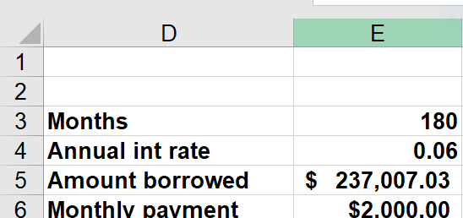
152 | Reads:  In cell E6, the formula =–PMT(annual_int_rate/12,years,amt._borrowed) computes the monthly payment associated with the amount borrowed, which is listed in cell E5. Filling in the Goal Seek  Should read:  In cell E6, the formula =-PMT(annual_int_rate/12,months,amt_borrowed) computes the monthly payment associated with the amount borrowed, which is listed in cell E5. Filling in the Goal Seek
288 | Reads:  Time Operators needed  Midnight–4 AM 12  4 AM–8 AM 16  8 AM–noon 22  Noon–4 PM 30  4 PM–8 PM 31  8 PM–midnight 22  Should Read:  Time Operators needed  Midnight–4 AM 12  4 AM–8 AM 16  8 AM–noon 22  Noon–4 PM 27  4 PM–8 PM 31  8 PM–midnight 22
289 | Location on page: Figure 31-4  Please replace figure 31-4 with this new one:  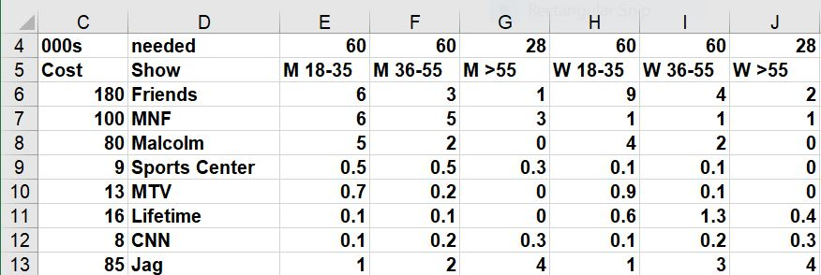
294 | Reads:  Production location 1 2 3 4 5 6  Sales price $45 $40 $38 $36 $39 $34  Tax rate 31% 40% 20% 40% 35% 18%  Variable production cost $8 $7 $6 $9 $7 $7  Should Read:  Production location 1 2 3 4 5 6  Sales price $45 $40 $38 $36 $39 $34  Tax rate 30% 40% 20% 40% 35% 18%  Variable production cost $8 $7 $6 $9 $7 $7
326 | Wrong number in table  Reads:  X Y Number of employees  5 20 6  50 50 12  25 75 23  80 30 15  Should Read:  X Y Number of employees  5 20 6  50 90 12  25 75 23  80 30 15
634 | Location on page: 3rd paragraph in 3rd bullet  Description of error: I believe that the following paragraph was meant to prove that events A and B are NOT independent after removing the 2 of spades.  Reads:  Now suppose that before drawing the card, we remove the 2 of spades from the deck. Are the events A and B still independent? Now P(A) = 12/51, P(B) = 4/51, and P(A and B) = 1/51. Since (12/51)*(4/51) is not (1/51), events A and B are independent.  Should Read:  Now suppose that before drawing the card, we remove the 2 of spades from the deck. Are the events A and B still independent? Now P(A) = 12/51, P(B) = 4/51, and P(A and B) = 1/51. Since (12/51)*(4/51) is not (1/51), events A and B are not independent.
650 | Location on page: bottom, last paragraph  Reads:  Let x equal the number of ticket holders who show up for the flight. You have n=105 and p=0.95. You seek the probability that x≥101. Note that the probability that x≤101 equals 1 minus the probability that x≤100. So, to compute the probability that the flight is overbooked, you enter in cell C10 the formula =1–BINOM.DIST(100,105,0.95,1)  Should read:  Let x equal the number of ticket holders who show up for the flight. You have n=105 and p=0.95. You seek the probability that x≥101. Note that the probability that x≥101b equals 1 minus the probability that x≤100. So, to compute the probability that the flight is overbooked, you enter in cell C10 the formula =1–BINOM.DIST(100,105,0.95,1)
667 | Problem 12 and solution should be changed  Reads:  Assume the mean daily percentage change in the Dow Jones Index is 1 percent, with a standard deviation of 1.5 percent.  Should Read:  Assume the mean daily percentage change in the Dow Jones Index is 0.01% percent, with a standard deviation of 1.5 percent.
726 | Before figure 79-4 – there isn’t enough info about the screen shot  Before figure 79-4, add the following text:  If you own a put or call, the effect of changing an input parameter on the value of the put or call that you own is shown in the following table:

